Population Bulletin
Emirate of Dubai
2020
1. Population
1.1 Population Size ⁽¹⁾
The population size of the Emirate of Dubai is estimated by 3,411,200 individuals at the end of 2020, of whom 2,362,255 are males and 1,048,945 are females with rates of 69.25% and 30.75% respectively of the total population. The higher proportion of males in Dubai community (225 Males per 100 Females) is attributed to the fact that the majority of expatriate workers are males who are not accompanying their family members, this is a kind of privacy that characterizes the demographic structure of the emirate, as the male and female ratio is balanced at the household level. Table 1 shows the distribution of the Emirate of Dubai population by gender at the end of 2020.
Table 1 - Population by Gender, Emirate of Dubai - End of 2020
% | Number | Gender
69.25 | 2,362,255 | Male
30.75 | 1,048,945 | Female
100.00 | 3,411,200 | Total
Source: Dubai Statistics Center –Yearly Population Estimates

1.2 Estimate of Active Individuals During Peak Hours “the Day”
The estimated number of active individuals during peak hours “the usual” in Dubai are 4,420,370 individuals which includes residents, individuals working in the governmental (federal, local) and private sectors in Dubai and residing outside the Emirate, the average number of tourists and sailors in addition to dynamic movement of people coming into and leaving the emirate during peak hours “the usual daily peak hours from Saturday to Thursday 6:30 am to 8:30 pm”.
The increasing movement of people during peak hours is attributed to two main reasons:
- Dubai is a commercial and tourist city that attracts residents of neighboring emirates, whether shopping, tourism and to manage their own businesses or work for others.
- The cheaper accommodation rates in neighboring emirates which lead public and private sectors employees in Dubai to inhabit in these neighboring emirates.

Table 2 - Active Individuals Movement During Peak Hours, Emirate of Dubai - End of 2020
Number | Description
3,411,200 | Population Usually Residing in Dubai ⁽²⁾
1,009,170 | Workers Residing Outside Dubai & Temporary Residents ⁽³⁾
4,420,370 | Total Active Individuals During Peak Hours
Source: Dubai Statistics Center - Yearly Population Estimates

Graph 1 - Active Individuals' Movement During Peak Hours,
Emirate of Dubai- End of 2020

2. Distribution of Usually Residents by Age Groups
The age and gender structure of Dubai population is considered as unbalanced (unnatural). This unbalanced structure is ascribed to the large proportion of foreign workers, most of which are working-age males in particular, which is a result of rapid economic growth witnessed by the emirate. This is shown clearly by Figure 2 which displays the population pyramid of Dubai at the end of 2020.
In addition, about 58.50% of the population is concentrated in the 25-44 age group where the 30-34 age group has the highest number of individuals 611,437 which represents 17.93% of total population, followed by the 25-29 age group with 565,679 individuals and a percentage of 16.58% of the population. Moreover, the 35-39 age group comes in the third place with 455,129 individuals and a percentage of 13.34% of total population.

Table 3- Population by Age Group and Gender, Emirate of Dubai - End of 2020 ⁽⁴⁾
% | Total | Female | Male | Age Group
5.31 | 181,180 | 87,026 | 94,154 | 0-4
5.15 | 175,626 | 88,379 | 87,247 | 5-9
4.40 | 149,948 | 74,070 | 75,878 | 10-14
3.34 | 113,880 | 54,416 | 59,464 | 15-19
7.82 | 266,887 | 75,736 | 191,151 | 20-24
16.58 | 565,679 | 144,668 | 421,011 | 25-29
17.93 | 611,437 | 156,410 | 455,027 | 30-34
13.34 | 455,129 | 130,283 | 324,846 | 35-39
10.65 | 363,315 | 89,882 | 273,433 | 40-44
6.81 | 232,446 | 51,730 | 180,716 | 45-49
3.60 | 122,846 | 40,642 | 82,204 | 50-54
2.68 | 91,270 | 25,794 | 65,476 | 55-59
1.24 | 42,432 | 13,815 | 28,617 | 60-64
0.56 | 19,230 | 6,129 | 13,101 | 65-69
0.26 | 8,779 | 4,355 | 4,424 | 70-74
0.33 | 11,116 | 5,610 | 5,506 | 75+
100.00 | 3,411,200 | 1,048,945 | 2,362,255 | Total
Source: Dubai Statistics Center - Yearly Population Estimates
Graph 2 -Population Pyramid, Emirate of Dubai - End of 2020

3. Population Distribution by Sector
Dubai is divided into 9 sectors. In light of the population distribution according to the main sectors in 2020, it is clear that the highest population concentration is in sector 3 with 1,260,218 residents and 36.94% of total population, followed by sector 2 with a concentration of 667,719 residents and 19.57%, while sector 1 comes in the third place with 475,842 residents and 13.95% of total population. Additionally, sectors 7-9 reached 68,898 residents with 2.02% of total population as shown in the table below.

Table 4 - Population by Sectors, Emirate of Dubai - End of 2020 ⁽⁴⁾
% | Population | Sector
13.95 | 475,842 | (1)
19.57 | 667,719 | (2)
36.94 | 1,260,218 | (3)
2.51 | 85,457 | (4)
13.25 | 451,952 | (5)
11.76 | 401,114 | (6)
0.43 | 14,628 | (7)
1.25 | 42,675 | (8)
0.34 | 11,595 | (9)
100.00 | 3,411,200 | Total
Source: Dubai Statistics Center –Yearly Population Estimates

Graph 3 - Dubai Population Map by Sectors- End of 2020
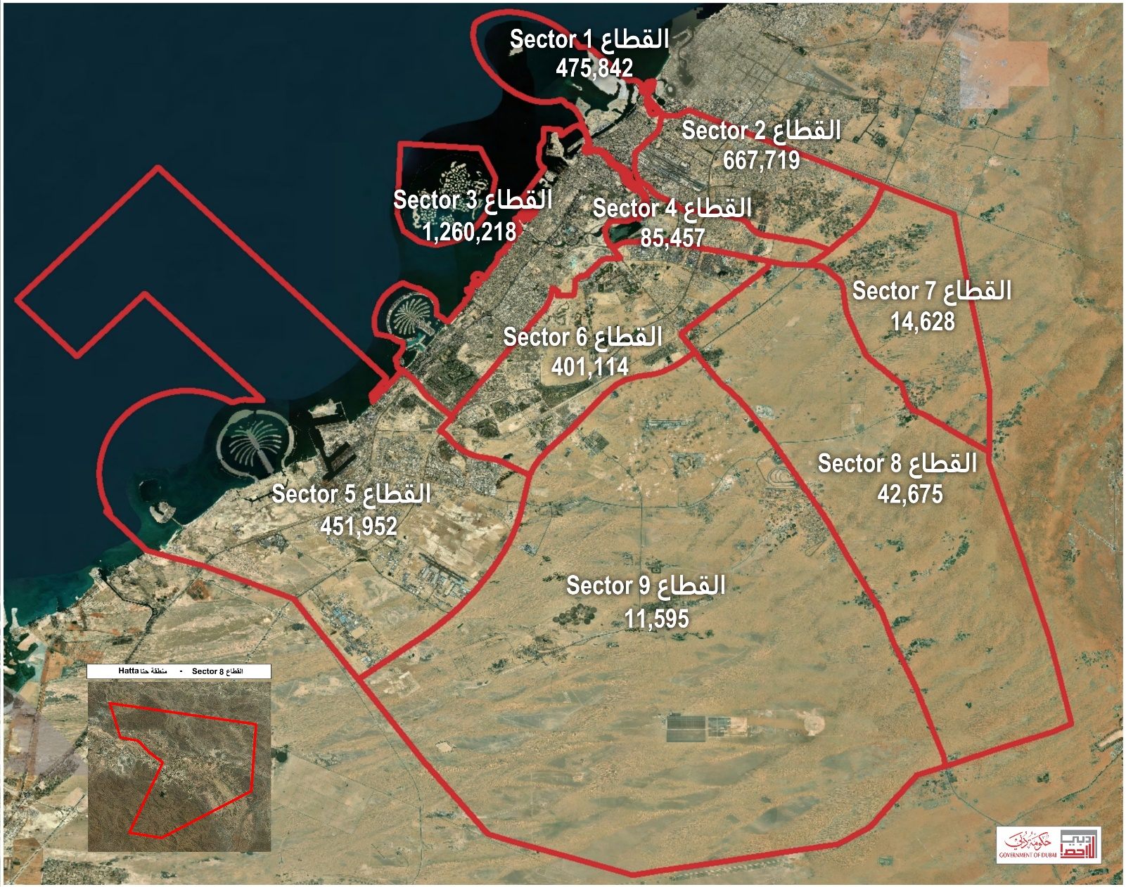
4. Distribution of Population by Communities
Collecting data about the distribution of population by communities is significant for planning purposes. It provides facts that portray the picture of the population size in each region for planners and decision makers which allows them to generate necessary plans and programs taking into account the context of each community. This will help in meeting the needs of public facilities and services of each of those communities.
As described in table 5 below, MUHAISANAH SECOND (264) has the highest number of population with 194,618 individuals that represents 5.71% of Dubai population. This community is followed by AL GOZE IND. SECOND (365) with160,517 individuals and a percentage of 4.71%. Moreover, JABAL ALI INDUSTRIAL FIRST (599) comes in the third place with a population size of 147,777 individuals and a percentage of 4.33% preceding the WARSAN FIRST Area (621) that has a population of 106,601 individuals and a percentage of 3.13%. These four Dubai communities together have a population size of 609,513 individuals and represent 17.88% of the total population size of the Emirate of Dubai. Those later figures can be explained by the presence of several labor accommodation camps in the mentioned above communities.

Table 5 - Population by Communities, Emirate of Dubai - End of 2020 ⁽⁴⁾
% | Population | Community Name | Community No.
= | 2 | NAKHLAT DEIRA⁽⁵⁾ | 101
0.06 | 1,961 | AL CORNICHE | 111
0.22 | 7,537 | AL RASS | 112
0.47 | 15,985 | AL DHAGAYA | 113
0.08 | 2,869 | AL BUTEEN | 114
0.12 | 4,020 | AL SABKHA | 115
0.57 | 19,414 | AYAL NASIR | 116
1.15 | 39,227 | AL MURAR | 117
1.48 | 50,438 | NAIF | 118
0.31 | 10,623 | AL REGA | 119
= | 14 | CORNICHE DEIRA⁽⁵⁾ | 121
0.73 | 24,961 | AL BARAHA | 122
1.36 | 46,510 | AL MUTEENA | 123
2.06 | 70,112 | AL MURQABAT | 124
0.21 | 7,216 | REGA AL BUTEEN | 125
0.51 | 17,481 | ABU HAIL | 126
2.45 | 83,529 | HOR AL ANZ | 127
0.06 | 2,016 | AL KHBEESI | 128
0.40 | 13,708 | PORT SAEED | 129
0.01 | 485 | AL HAMRIYA PORT | 131
0.62 | 21,018 | AL WAHEDA | 132
0.63 | 21,430 | HOR AL ANZ EAST | 133
0.45 | 15,286 | AL MAMZER | 134
0.09 | 3,200 | NAD SHAMMA | 213
0.55 | 18,746 | AL GARHOUD | 214
0.09 | 2,958 | UM RAMOOL | 215
1.10 | 37,493 | AL RASHIDIYA | 216
= | 22 | DUBAI AIRPORT⁽⁵⁾ | 221
0.34 | 11,687 | AL TWAR FIRST | 226
0.14 | 4,909 | AL TWAR SECOND | 227
0.32 | 10,837 | AL TWAR THIRD | 228
0.93 | 31,828 | AL NAHDA FIRST | 231
1.35 | 46,210 | AL QUSAIS FIRST | 232
0.37 | 12,654 | AL QUSAIS SECOND | 233

% | Population | Community Name | Community No.
0.21 | 7,263 | AL QUSAIS THIRD | 234
1.84 | 62,706 | AL NAHDA SECOND | 241
0.28 | 9,511 | AL QUSAIS IND. FIRST | 242
0.26 | 8,967 | AL QUSAIS IND. SECOND | 243
0.19 | 6,649 | MUHAISANAH THIRD | 244
1.03 | 35,083 | MUHAISANAH FOURTH | 245
0.10 | 3,524 | AL QUSAIS IND. THIRD | 246
0.08 | 2,751 | AL QUSAIS IND. FOURTH | 247
0.06 | 2,034 | AL QUSAIS IND FIFTH | 248
1.91 | 65,044 | MURDAF | 251
= | 67 | MUSHRAIF PARK⁽⁵⁾ | 252
0.24 | 8,283 | MUHAISANAH FIRST | 261
0.50 | 16,968 | AL MEZHAR FIRST | 262
0.34 | 11,600 | AL MEZHAR SECOND | 263
5.71 | 194,618 | MUHAISANAH SECOND | 264
0.44 | 15,052 | OUD AL MUTEEN FIRST | 265
0.17 | 5,647 | OUD AL MUTEEN SECOND | 266
= | 2 | MUHAISANAH FIFTHMUHAISANAH FIFTH⁽⁵⁾ | 267
0.20 | 6,847 | OUD AL MUTEEN THIRD | 268
0.10 | 3,451 | WADI ALAMRADI | 271
0.39 | 13,206 | AL KHAWANEEJ ONE | 281
0.16 | 5,322 | AL KHAWANEEJ TWO | 282
0.05 | 1,770 | AL AYAS | 283
0.02 | 810 | AL TTAY | 284
= | 39 | JUMEIRA BAY ⁽⁵⁾ | 302
= | 7 | WORLD ISLANDS ⁽⁵⁾ | 303
= | 3 | JUMEIRA ISLAND 2 ⁽⁵⁾ | 304
= | 7 | AL SHANDAGA⁽⁵⁾ | 311
1.50 | 51,293 | AL SUQ AL KABEER | 312
1.09 | 37,012 | AL HAMRIYA | 313
0.17 | 5,950 | UM HURAIR FIRST | 314
0.16 | 5,414 | UM HURAIR SECOND | 315
1.40 | 47,652 | AL RAFFA | 316
1.19 | 40,520 | AL MANKHOOL | 317
2.22 | 75,560 | AL KARAMA | 318
0.44 | 15,061 | OUD METHA | 319

% | Population | Community Name | Community No.
0.43 | 14,753 | MADINAT DUBAI AL MELAHEYAH (AL MINA) | 321
0.42 | 14,372 | AL HUDAIBA | 322
0.71 | 24,281 | AL JAFLIYA | 323
= | 2 | AL KIFAF⁽⁵⁾ | 324
0.10 | 3,331 | ZAABEEL FIRST | 325
0.17 | 5,873 | AL JADAF | 326
0.61 | 20,715 | JUMEIRA FIRST | 332
1.69 | 57,487 | AL BADA | 333
1.15 | 39,297 | AL SATWA | 334
0.49 | 16,734 | TRADE CENTER FIRST | 335
0.36 | 12,419 | TRADE CENTER SECOND | 336
0.24 | 8,258 | ZAABEEL SECOND | 337
0.30 | 10,284 | JUMEIRA SECOND | 342
0.34 | 11,725 | AL WASL | 343
0.61 | 20,795 | BURJ KHALIFA | 345
0.63 | 21,497 | AL KALIJ AL TEJARI | 346
0.04 | 1,457 | AL MERKADH | 347
0.40 | 13,690 | JUMEIRA THIRD | 352
0.26 | 8,722 | AL SAFFA FIRST | 353
0.60 | 20,573 | AL GOZE FIRST | 354
0.16 | 5,354 | AL GOZE SECOND | 355
0.35 | 11,947 | UM SUQAIM FIRST | 356
0.20 | 6,823 | AL SAFFA SECOND | 357
1.19 | 40,556 | AL GOZE THIRD | 358
0.69 | 23,403 | AL GOZE FOURTH | 359
0.37 | 12,572 | UM SUQAIM SECOND | 362
0.25 | 8,443 | AL MANARA | 363
0.76 | 25,860 | AL GOZE IND. FIRST | 364
4.71 | 160,517 | AL GOZE IND. SECOND | 365
0.22 | 7,672 | UM SUQAIM THIRD | 366
0.13 | 4,464 | UM AL SHEIF | 367
0.75 | 25,504 | AL GOZE IND. THIRD | 368
1.10 | 37,360 | AL GOZE IND. FOURTH | 369
0.13 | 4,516 | AL SAFOUH FIRST | 372
1.18 | 40,202 | AL BARSHAA FIRST | 373

% | Population | Community Name | Community No.
0.44 | 14,947 | AL BARSHAA THIRD | 375
0.47 | 15,901 | AL BAESHAA SECOND | 376
0.73 | 24,741 | NAKHLAT JUMEIRA | 381
0.18 | 6,226 | AL SOFOUH SECOND | 382
0.74 | 25,202 | AL THANYAH FIRST (V. RABIE SAHRA'A) | 383
= | 115 | AL THANYAH SECOND (JEBEL ALI HORSE RACING) ⁽⁵⁾ | 384
0.64 | 21,769 | AL THANYAH THIRD (EMIRATE HILLS SECOND) | 388
1.82 | 61,992 | MARSA DUBAI (AL MINA AL SEYAHI) | 392
1.21 | 41,185 | AL THANYAH FIFTH (EMIRATE HILLS FIRST) | 393
0.83 | 28,164 | AL THANYAH FOURTH (EMIRATE HILLS THIRD) | 394
0.15 | 5,060 | AL KHEERAN | 412
= | 2 | RAS AL KHOR⁽⁵⁾ | 413
0.03 | 947 | AL KHAIRAN FIRST | 415
0.43 | 14,571 | NAD AL HAMAR | 416
0.73 | 24,865 | AL WARQAA FIRST | 421
0.32 | 10,981 | AL WARQAA SECOND | 422
0.44 | 15,147 | AL WARQAA THIRD | 423
0.41 | 13,881 | AL WARQAA FOURTH | 424
0.0 | - | AL WARQAA FIFTH | 425
= | 3 | WADI ALSHABAK⁽⁵⁾ | 431
= | 5 | NAKHLAT JABAL ALI⁽⁵⁾ | 501
= | 4 | AL WAJEHAH AL BHARIYAH⁽⁵⁾ | 502
0.10 | 3,518 | HESSYAN FIRST | 511
0.30 | 10,398 | HESSYAN SECOND⁽⁵⁾ | 512
= | 15 | SAIH SHUAIB 1 ⁽⁵⁾ | 513
0.07 | 2,462 | JABAL ALI INDUSTRIAL THIRD | 516
0.67 | 23,000 | JABAL ALI INDUSTRIAL SECOND | 518
0.10 | 3,404 | MADINAT AL MATAAR | 521
0.43 | 14,511 | SAIH SHUAIB 2 | 531
0.24 | 8,200 | SAIH SHUAIB 3 | 532
0.33 | 11,170 | SAIH SHUAIB 4 | 533
2.23 | 76,016 | JABAL ALI FIRST | 591
0.05 | 1,573 | JABAL ALI SECOND | 592

% | Population | Community Name | Community No.
0.04 | 1,513 | JABAL ALI THIRD | 593
0.73 | 24,795 | MENA JABAL ALI | 594
1.60 | 54,474 | DUBAI INVESTMENT PARK2 | 597
2.03 | 69,117 | DUBAI INVESTMENT PARK1 | 598
4.33 | 147,777 | JABAL ALI INDUSTRIAL FIRST | 599
= | 2 | BU KADRA⁽⁵⁾ | 611
0.08 | 2,564 | RAS AL KHOR IND. FIRST | 612
0.07 | 2,529 | RAS AL KHOR IND. SECOND | 613
0.66 | 22,358 | RAS AL KHOR IND. THIRD | 614
0.07 | 2,486 | NAD AL SHIBBA SECOND | 615
0.03 | 1,098 | NAD AL SHIBBA THIRD | 616
0.11 | 3,779 | NAD AL SHIBBA FOURTH | 617
0.18 | 6,056 | NAD AL SHIBBA FIRST | 618
3.13 | 106,601 | WARSAN FIRST | 621
0.04 | 1,380 | WARSAN SECOND | 622
0.26 | 8,763 | WARSAN FOURTH | 624
1.15 | 39,131 | NADD HESSA | 626
0.05 | 1,688 | HADAEQ SHEIKH MOHAMMED BIN RASHID | 631
0.31 | 10,678 | WADI AL SAFA 2 | 643
0.29 | 9,906 | WADI AL SAFA 3 | 645
= | 160 | WADI AL SAFA 4⁽⁵⁾ | 646
0.63 | 21,536 | WADI AL SAFA 5 | 648
0.54 | 18,511 | WADI AL SAFA 6 (ARABIAN RANCHES) | 664
0.25 | 8,613 | WADI AL SAFA 7 | 665
0.41 | 14,069 | AL BARSHA SOUTH FIRST | 671
0.22 | 7,661 | AL BARSHA SOUTH SECOND | 672
0.21 | 7,023 | AL BARSHA SOUTH THIRD | 673
0.32 | 10,767 | AL HEBIAH FIRST | 674
0.05 | 1,546 | AL HEBIAH SECOND | 675
0.20 | 6,955 | AL HEBIAH THIRD | 676
0.07 | 2,359 | AL HEBIAH SIXTH | 677
0.77 | 26,331 | AL BARSHA SOUTH FOURTH | 681
0.61 | 20,916 | AL HEBIAH FOURTH | 682
0.29 | 9,897 | AL HEBIAH FIFTH | 683
0.22 | 7,506 | AL BARSHA SOUTH FIFTH | 684

% | Population | Community Name | Community No.
0.53 | 18,233 | ME'AISEM FIRST | 685
= | 12 | ME'AISEM SECOND ⁽⁵⁾ | 686
0.13 | 4,312 | AL AWEER ONE | 711
0.17 | 5,710 | AL AWEER TWO | 721
= | 2 | ENKHALI⁽⁵⁾ | 724
= | 46 | AL WOHOOSH⁽⁵⁾ | 727
0.10 | 3,243 | LEHBAB FIRST | 731
0.02 | 760 | AL MERYAL | 735
0.02 | 555 | NAZWAH | 736
0.44 | 14,943 | WARSAN THIRD | 811
0.09 | 3,152 | AL ROWAIYAH FIRST | 812
0.00 | - | AL ROWAIYAH SECOND | 813
0.13 | 4,494 | AL ROWAIYAH THIRD | 814
0.03 | 1,120 | MEREIYEEL | 821
0.01 | 287 | UMM AL DAMAN | 824
= | 53 | LE HEMAIRA⁽⁵⁾ | 826
0.04 | 1,530 | LEHBAB SECOND | 831
0.01 | 310 | UMM AL MO'MENEEN | 835
0.03 | 1,023 | MARGHAM | 841
0.01 | 195 | AL MAHA | 845
0.01 | 206 | UMM ESELAY | 847
0.01 | 232 | REMAH | 851
0.02 | 635 | MARGAB | 857
= | 95 | YARAAH⁽⁵⁾ | 861
0.42 | 14,400 | HATTA | 891
= | 8 | UMM NAHAD FIRST⁽⁵⁾ | 911
= | 2 | UMM NAHAD SECOND ⁽⁵⁾ | 912
0.04 | 1,347 | UMM NAHAD THIRD | 913
= | 4 | UMM NAHAD FOURTH⁽⁵⁾ | 914
0.01 | 403 | AL YUFRAH 1 | 915
0.03 | 858 | AL YUFRAH 2 | 916
= | 96 | AL MARMOOM⁽⁵⁾ | 917
0.02 | 711 | AL YUFRAH 3 | 918
= | 3 | AL YUFRAH 4 ⁽⁵⁾ | 919
0.03 | 1,130 | AL YALAYIS 1 | 921
0.04 | 1,380 | AL YALAYIS 2 | 922

% | Population | Community Name | Community No.
= | 4 | AL YALAYIS 3 ⁽⁵⁾ | 923
= | 8 | AL YALAYIS 4 ⁽⁵⁾ | 924
= | 100 | AL YALAYIS 5⁽⁵⁾ | 925
0.09 | 2,906 | AL LESAILY | 931
= | 55 | GRAYTEESAH⁽⁵⁾ | 941
0.01 | 425 | AL FAGAA' | 945
0.02 | 608 | SAIH AL SALAM | 951
= | 35 | AL HATHMAH ⁽⁵⁾ | 956
0.02 | 666 | AL SELAL | 961
= | 32 | GHADEER BARASHY⁽⁵⁾ | 967
= | 3 | SAIH AL DAHAL⁽⁵⁾ | 971
= | 3 | AL O'SHOOSH ⁽⁵⁾ | 975
= | 3 | SAIH SHUA'ALAH ⁽⁵⁾ | 978
0.02 | 805 | MUGATRAH | 981
0.00 | - | AL LAYAN 1 | 987
0.00 | - | AL LAYAN 2 | 988
0.00 | - | HEFAIR | 991
100.00 | 3,411,200 | Total
Source: Dubai Statistics Center –Yearly Population Estimates

ــــــــــــــــــــــــــــــــــــــــــــــــــــــــــــــــــــــــــــــــــــــــــــــــــــــــــــــــــــــــــــــــــــــــــــــــــــــــــــــــــــــــــــــــــــــــــــــــــــــــــــــــــــــــــــــــــــ
⁽¹⁾ Population are all individuals living within the geographical boundaries of the Emirate, whether they have citizenship of, or were residents based on the population census or the population projections.
⁽²⁾ Estimated based on the Dubai Population Statistics 2016 & 2017 & 2018 Results.
⁽³⁾ Includes a percentage of federal and local governments, and private sector employees who resides outside the Emirate plus the average number of tourists and sailors.
⁽⁴⁾ Estimated.
⁽⁵⁾ Value less than the unit of measure.

